Optimizing Chunking, Embedding, and Prompting in a Retrieval-Augmented Generation Pipeline
Ritwik Jayaraman

Important Notes
Due to time constraints, all experiments were run on a randomized set of half of the dataset (555 examples per experiment). Additionally, much of the code was taken from my AI Forge project. Thus, the code could not have been possible without the contributions of Professor Bruno Riberio and Steven Kiss. I thank them both for their help. ChatGPT was used to generate some basic helper functions, but rest of the code was made by me or in collaboration with others in the AI Forge Project.
Due to the design of my experiments, I felt that it would be better to explain and evaluate each experiment first before introducing the next one. This is because the results for prior experiments are used in future ones (e.g. best embedding model identified in Experiment 1 is used in Experiments 2-4). Following academic paper format, each experiment has its own Introduction, Methodology, Results, and Discussion sections.
Abstract
Retrieval-Augmented Generation (RAG) systems combine information retrieval with large language models to improve factual grounding, yet their performance depends heavily on design choices such as retrieval method, chunking strategy, and prompt construction. In this project, I extend a Wiki-based question-answer pipeline by replacing BM25 retrieval with dense semantic retrievers, integrating Milvus for vector storage, and experimenting with embedding models of varying sizes and dimensions. I systematically evaluate how chunk size, overlap, and embedding dimension affect retrieval quality and answer accuracy. Surprisingly, I find that using no chunk overlap yields better results than overlapping chunks, suggesting that there are redundant or less relevant text near chunk boundaries. Among the embedding models tested, Nomic achieved the best balance of accuracy and efficiency, outperforming larger models from Qwen and Gemma. Finally, I introduce an k-shot prompting strategy that retrieves contextually similar examples based on question type and difficulty, further improving coherence and conciseness in generated answers. Together, these results highlight the sensitivity of RAG performance to design choices.
1 Experiment 1 Introduction, Methodology, Results, and Discussion
1.1 Motivation for Question/Experiment 1
In the past labs, our work has revolved around the use of BM25, a lexical retriever. Although BM25 considers some drawbacks of lexical retrievers (e.g. it puts less weight on common words because of how frequently they appear in passages), the retriever doesn’t consider any semantic meaning behind the text. This is of concern because even if two similar phrases have similar ideas but use different words, they won’t be retrieved together. Therefore, I propose to use a semantic retriever to vectorize the wiki passages we have been given. Because of the increased complexity of such a retriever in comparison to BM25, the hope is to see significant improvements in both EM and F1 metrics.
1.2 Question 1 Stated and Experiment 1 Details
The first question I hope to answer is “Are semantic retrievers able to produce better results than BM25?” To answer this, we test Qwen3-Embedding-0.6B, embeddinggemma-300m, and nomic-embed-text-v1.5. All these models are both fairly lightweight in terms of their size yet are some of the most popular embedding models out there, each with over a million lifetime downloads. However, I wanted to test models which varied in both their default embedding dimension size and how they placed on the Massive Text Embedding Benchmark (MTEB) leaderboard (Hugging Face, n.d.). For example, Nomic’s model placed 80th on the leaderboard, while the former two models both placed within the top 10. Additionally, Qwen’s embedding size is 1024 dimensions, while Gemma and Nomic’s embeddings are 768 dimensions.
To test these model’s base embedding capabilities against each other, we embed the wiki passages from wiki_snippets_dev.json, and then randomly sample half of the dev.jsonl dataset to derive F1 and exact match (EM) metrics (same metrics used in previous experiments) from Llama-3.1-8B-Instruct’s responses. For each model, we embed both the question and its context chunk together, as the chunk is meant to “answer” the question directly in our dataset. This is the same process that was used for all prior experiments, so we continue to do so here for continuity. The model was given 7 retrieved context chunks per user query, as n=7 was the best n previously found when retrieving context via BM25. To standardize this experiment, we needed to choose hyperparameters, particularly the chunk size and overlap, to be the same across all embedding models. We chose the chunk size as 256 tokens because this is a common chunk size that has been used throughout academia and has been proven to lead to overall accurate results (Wang et al., 2024; Milvus, 2024). An overlap of 25% of the chunk size was chosen to ensure that each chunk would have sufficient context, but not too much overlap that would significantly increase the number of chunks retrieved. Cosine similarity between embedded vectors was used, as this measure is widely used throughout literature and is one of the easiest to implement. Finally, we use Milvus as our vector database, as it’s been widely revered as a comprehensive database for all RAG solutions, and it’s been personally recommended to me by faculty at Purdue (Wang et al., 2024). You can see below as an example of the formatted prompt used for this experiment.
Prompt Format
<|begin_of_text|><|start_header_id|>system<|end_header_id|>
You are a helpful assistant whose job it is to answer general knowledge questions. Please answer concisely. Below is some context before the user's query to help you answer the question.<|eot_id|>
<|start_header_id|>context<|end_header_id|>
{context_1 text}<|eot_id|>
….. (7 context chunks retrieved in this case, so this same pattern repeats)
<|start_header_id|>user<|end_header_id|>
{user query text}<eot_id|>
<|start_header_id|>assistant<|end_header_id|>
1.3 Experiment 1 Results and Discussion
Figure 1 shows the results in comparison with our best Wiki retrieval and random in-context learning retrieval. Surprisingly, all our semantic retrievers did worse than randomized/lexical retrieval examples. One reason why could be because our wiki “passages” were really retrieved paragraphs that were targeted towards answering the specific question being asked. Thus, there wasn’t much the semantic retrievers could do in terms of extracting different information in comparison to the Wiki BM25 retrieval. Additionally, these retrievers result in a lower EM score than the randomized retrieval experiment. This may be because the model tried to generate output that was similar in length to the Wikipedia passages. Note that in the randomized retrieval experiment, we only generated example question-answer pairs and injected that into the prompt. It’s explored how to reduce the responses’ length in Experiment 4, which is discussed later in the report.
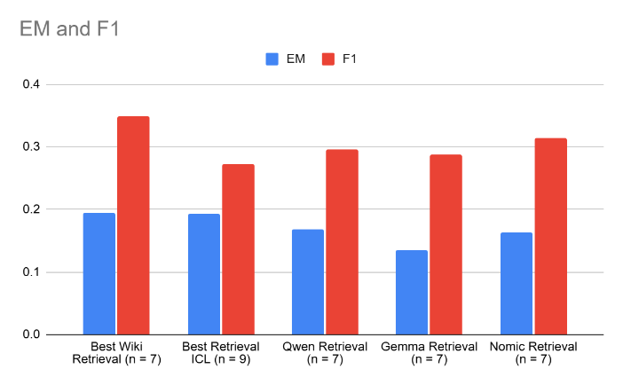
Figure 1
To answer the question we first posed, it seems that the Nomic model had the best overall accuracy scores. This was surprising, as Nomic is smallest model of the three tested (100m parameters in comparison to 300m for Gemma and 600m for Qwen). When inspecting further, I also found that Nomic retrieved the most correct chunks which corresponded with the user’s query. These slight differences between the models may be due to how each were trained, therefore making Nomic’s architecture slightly fit the task better. Because of Nomic’s performance in this experiment, we will continue to use this model for all future experiments.
2 Experiment 2-3 Introduction, Methodology, Results, and Discussion
2.1 Motivation for Questions/Experiments 2 and 3
With these LLM/RAG technologies, one of the most important questions users ask is “which values do I set my hyperparameters to?” This is of common interest for any experiment, as these parameters greatly influence how long it takes for RAG pipelines to return responses and how much memory these pipelines would demand. Two of these hyperparameters are of great interest: embedding dimension and chunk overlap. For the former, more dimensions can lead to greater semantic information being captured, thus leading to more successful retrieval. However, more dimensions also mean more strain on computational resources, such as compute power and memory. For chunk overlap, having some amount of overlap means that coherence between chunks will be preserved. However, such overlap leads to more chunks needing to be created, thus demanding more of the user’s computational resources.
2.2 Questions 2-3 Stated and Experiment 2-3 Details
This motivation leads us to the following questions:
- Question 2: If we lower the embedding dimension size, can we still preserve the accuracy of the pipeline?
- Question 3: If we set the chunks to have no overlap with each other, can we still preserve the accuracy of the pipeline?
To answer Question 2, we will use a similar procedure to Experiment 1. However, we will vary the embedding size to two other factors (128, 512) to quantify how much our LLM’s accuracy changes as a result. It is important to note that nomic-embed-text-v1.5 was specifically trained with Matryoshka Representation Learning, or MRL (Nomic AI, 2024). This means that it was trained to learn representations at different dimension sizes, thus allowing the model to support variable embedding size. Regardless, it will still be of interest to quantify how much our results differ when changing only this hyperparameter.
After the best embedding dimension is found, we will repeat Experiment 2, but this time only the context overlap size will vary. For each run of our pipeline, our chunks will either have an overlap of 64 tokens (chunk size is 256 tokens) or a chunk size of 0 tokens. Note that for both experiments, we again report the EM and F1 metrics.
2.3 Experiments 2-3 Results and Discussion
Figure 2 shows the results in comparison with our best Wiki retrieval and Experiment 1 results for Nomic. F1 scores are around the same for all trials. However, EM seems to slowly decrease as the embedding dimension gets smaller. This makes sense because with less dimensions, there is less of an ability for the model to “store” information about a phrase’s semantic meaning. However, because of the model’s usage of MRL, these metrics only dropped off by 0.013 at most. Overall, we found that 768 dimensions still produced the best results overall.
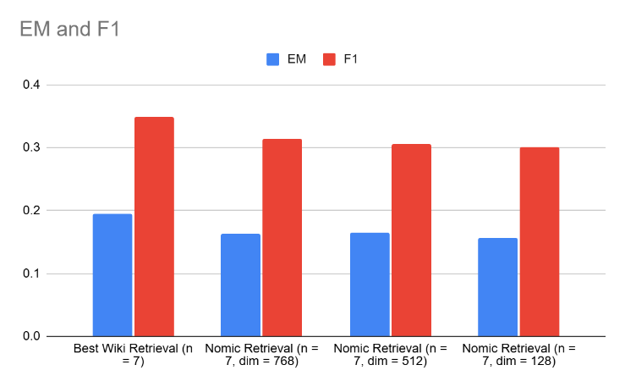
Figure 2
Figure 3 shows the results in comparison with our best Wiki retrieval. We find that when we have no chunk overlap, our pipeline performs better than with overlap, which is a surprising conclusion. Upon further analysis, I found that when we had chunk overlap, we only created 100 more chunks in comparison to when we had a chunk overlap of 64 tokens. This means that most passages were less than 256 tokens long. Additionally, when analyzing the Wiki passages, it’s clear that the information towards the end of the chunk is less relevant than the information at the beginning. Thus, when we created more chunks with the addition of an overlap, these chunks likely wouldn’t have contained relevant information. Thus, by removing these worthless chunks by having no overlap, we get better results.
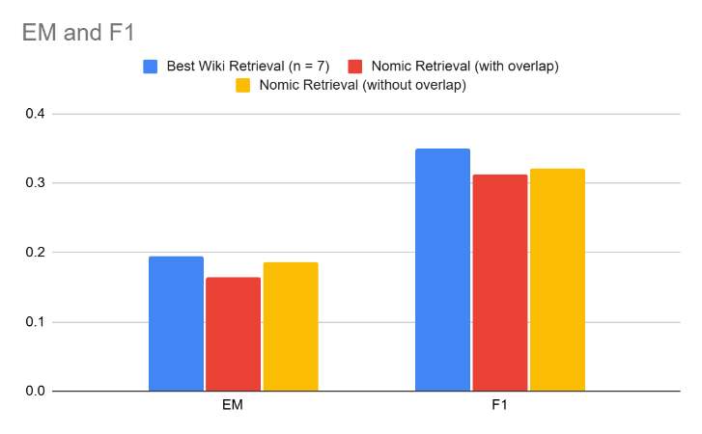
Figure 3
3 Experiment 4 Introduction, Methodology, Results, and Discussion
3.1 Motivation for Questions/Experiment 4 and Question 4 Stated
Finally, a drawback observed thus far was that although context was injected into the prompt, we never gave the model specific question-answer example pairs to model its response from. This led to longer responses, even when it was specified in the system prompt to be concise, and therefore worse results (since the ground truth responses are usually concise). Thus, if we can combine n-shot prompting techniques and inject relevant context into our overall prompt, there is promise for improved results without having to make drastic changes to the transformer models being implemented. Therefore, the following question arises: “If we were to provide the model with context-question-answer examples, would we see improved and more concise responses?”
3.2 Experiment 4 Details
Using the best identified embedding model, embedding size, and overlap size in the previous experiments, we will make a prompt that not only has context for the current query but also has context-question-answer examples as well. For every user query, we also obtain k (k = 1, 2, or 3) question-answer pairs from the dev dataset that are of the same difficulty level and question type. Then, we retrieve the context for these queries and inject them into our prompt (we keep that 7 context chunks are retrieved for each question). An example prompt with k = 1 can be seen below:
Prompt Format
<|begin_of_text|><|start_header_id|>system<|end_header_id|>
You are a helpful assistant whose job it is to answer general knowledge questions. Please answer concisely. Below is some question-answer pairs as examples (marked with example and line breaks), along with context for these examples. After this, we have included some context before the user's query to help you answer the question.<|eot_id|>

<|start_header_id|>example<|end_header_id|>
<|start_header_id|>context<|end_header_id|>
{context_1 text}<|eot_id|>
….. (7 context chunks retrieved in this case, so this same pattern repeats)
<|start_header_id|>user<|end_header_id|>
{example query text}<eot_id|>
<|start_header_id|>assistant<|end_header_id|>
{example response text}<eot_id|>

<|start_header_id|>context<|end_header_id|>
{context_1 text}<|eot_id|>
….. (7 context chunks retrieved in this case, so this same pattern repeats)
<|start_header_id|>user<|end_header_id|>
{user query text}<eot_id|>
<|start_header_id|>assistant<|end_header_id|>
3.3 Experiment 4 Results and Discussion
Figure 4 shows the results in comparison with our best Wiki retrieval. It is clear that this proposed method is far better than the BM25 Wiki retrieval. This is likely because with question-answer pairs in addition to query-specific context, not only does the LLM have more information about the question, but it is also given information on how to format its response. Choosing examples that are of the same difficulty and type as the current user query seems to have also tailored the examples better to the current query. Note that we do see a slight decline in accuracy at k=3. This may be because with k = 3, the prompt is very long, so the overload in information may slightly confusing the LLM.
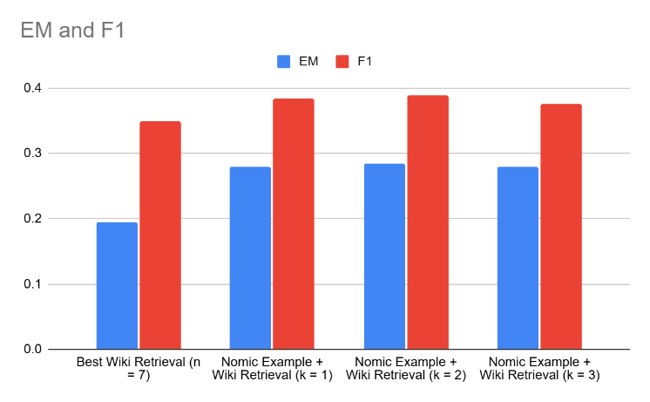
Figure 4
4 Final Results and Conclusions
Figure 5 shows the best result obtained from each experiment in both this lab and all past labs. Overall, it is clear that as we increase the amount of information given to the LLM, we get better responses up to a certain point. LLMs can sometimes be fed too much information, so the user must be careful about how they construct their prompt. Additionally, prompting the LLM to reason (e.g. with Chain of Thought (CoT) prompting) has led to great improvements for the LLM’s responses. This can be seen in Figure 5, where just CoT alone was able to generate the 2nd best EM among all of our experiments. Semantic retrieval, when combined with n-shot prompting, overall provided the best results of any experiment.
Although we worked with specific data in these experiments, the concepts implemented are generalizable to any LLM/RAG scenario. This is because the ideas implemented, especially in Experiment 4, were done after having considered what others in the field have implemented in the past.
In this project, I learned not only how valuable semantic retrieval is, but how powerful retrieval and n-shot prompting can be. However, semantic retrieval cannot just be implemented naively. Careful consideration must also be given to the various hyperparameters used, such as temperature, chunk size, and embedding dimension. These hyperparameters, as seen in the previous experiments, have a great effect on the accuracy of our LLM’s results.
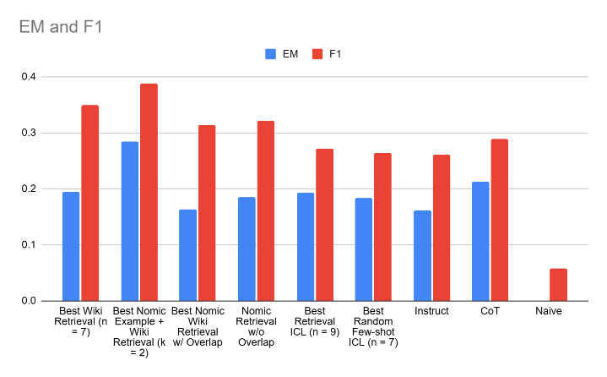
Figure 5
5 Future Directions
If given more time, I would like to explore using a cross-encoder reranker after the initial semantic retrieval. This technique has been shown to improve LLM responses in other scenarios, so I think it would be useful to quantify the change in accuracy brought by the reranker being introduced into our pipeline. Additionally, similar to how we tested different values for the chunk overlap and embedding dimension, I wish to do so for the chunk size as well. Although 256 tokens is a chunk size commonly used, it seems that for this specific context, the size may have been too large (note how only 100 more chunks were made when going from 0 token overlap to 64 token overlap). Thus, it would be interesting to see how tuning this parameter affects our results. This would also make our retrieval more important, as the embedding model have to choose from more chunks which ones to specifically retrieve.
References
Hugging Face. (n.d.). Massive Text Embedding Benchmark (MTEB) leaderboard. Hugging Face Spaces. Retrieved October 27, 2025, from https://huggingface.co/spaces/mteb/leaderboard
Milvus. (2024, June 18). What is the optimal chunk size for RAG applications? Milvus AI Quick Reference. Retrieved from https://milvus.io/ai-quick-reference/what-is-the-optimal-chunk-size-for-rag-applications
Nomic AI. (2024, April 30). Introducing Nomic Embed: Matryoshka embeddings for efficient retrieval and clustering. Nomic Blog. Retrieved from https://www.nomic.ai/blog/posts/nomic-embed-matryoshka
Wang, X., Wang, Z., Gao, X., Zhang, F., Wu, Y., Xu, Z., ... & Huang, X. (2024). Searching for best practices in retrieval-augmented generation. arXiv preprint arXiv:2407.01219.

